

|  |
| --- |
|  |
| computer organziation |
| Common Bus report |
|  |

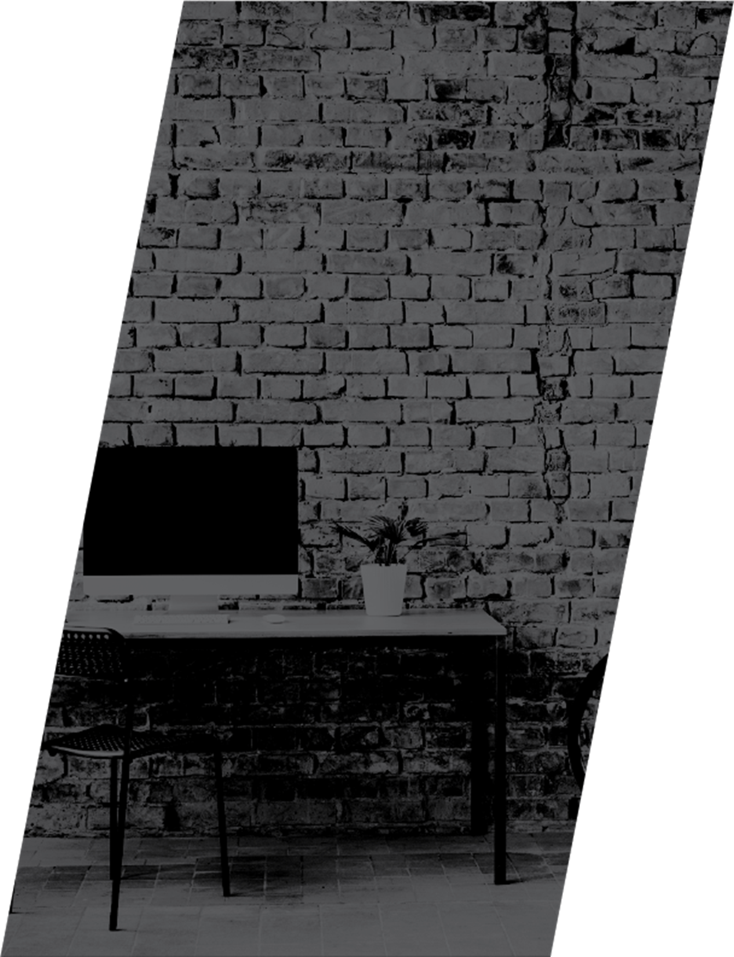

|  |  |
| --- | --- |
|  | Decorative |
| SUMMARY |
| **A Basic Computer includes many registers and information needs to transfer between these registers. A way to transfer the information is using the common bus system. In this Report we shall discuss the common bus system using multiplexers.**  **A bus structure consists of a set of common lines, one for each bit of a register, through which binary information is transferred one at a time.**  **Control signals determine which register is selected by the bus during each particular register transfer.**  **Bus systems can be designed using multiplexers and tri-state buffers.** |

|  |  |
| --- | --- |
|  | Decorative |
| **Block Diagram** |
| The following diagram shows the design of a four-register bus system. The bus is made up of 4x1 multiplexers with four inputs and one output, as well as four registers with numbers ranging from 0 to 3. S0 and S1 are two select inputs that are coupled to the multiplexers' select inputs.  Register A's output 1 is linked to MUX 1's input 0 and further connections are established as illustrated in the diagram. The data sent to the bus is determined by the select lines. |
|  |
| Figure 1 |

|  |  |  |
| --- | --- | --- |
|  |  | Decorative |
|  |  | **Truth Table** |
| Table  Description automatically generated  The Table shows the register that is selected by the bus for each of the four possible binary values of the selection lines.  When S1S0= 00, the 0 data inputs of all four multiplexers are selected and applied to the outputs that form the bus to the destination Register. This causes the bus lines to receive the content of register A since the outputs of this register are connected to the 0 data inputs of the multiplexers. Similarly, register B is selected if S1-S0= 01, and so on.  In general, a bus system will multiplex k registers of n bits each to produce an n-line common bus. The number of multiplexers needed to construct the bus is equal to n, the number of bits in each register. The size of each multiplexer must be K x 1 since it multiplexes K data lines. For example, a common bus for eight registers of 16 bits each requires 16 multiplexers, one for each line in the bus. Each multiplexer must have eight data input lines and three selection lines to multiplex one significant bit in the eight registers |

|  |  |
| --- | --- |
|  | Decorative |
| **components**  * Timer Ne(555) * Switches (3) * LEDs (4) * SN54153 (4 to 1 Multiplexers) * SN74LS173 (5 of the 4-bit shift Register) * Male to Male Jumper Wires * Capacitor (0.01 Micro Farads) * Resistors ( 1K ohm , 3K ohm)     **Data Sheets** |
| Diagram  Description automatically generatedDiagram, schematic  Description automatically generated  Data sheet of timer (555)  A picture containing text, receipt, screenshot  Description automatically generated  Data sheet of register    Data Sheet Of Multiplexer  **Hardware Circuit**     * Connect 4 switches to the inputs of each of the 4 source registers. Switches are connected to resistors ( 1K ohm ) to Ground as well. * Connect the outputs of the registers to the inputs of the multiplexers According to the data sheets as follows: Mux 1’s inputs are (Q0 of Reg. A, Q0 of Reg.B, Q0 of Reg. C & Q0 of Reg. D) Mux 2’s inputs are ( Q1 of Reg. A, Q1 of Reg. B, Q1 of Reg. C, & Q1 of Reg.D)…….etc. * Make sure that the enable lines are connected to VCC. Connect the Selection lines of all the multiplexers to each other then to two switches because each multiplexer carries one bit to the destination Register, so to select any of the 4 source Reg. we have to select all of its bits at the same time. * Each Mux has 1 output, so our 4 outputs go into the destination Reg. & subsequently, the outputs of the Reg. go to LEDs, the other(short) terminals of the LEDs are connected to Ground (Bec. LEDs have cathodes & anodes) * Registers need a load and a clock to work, the NE555 timer plays the role of the clock. |

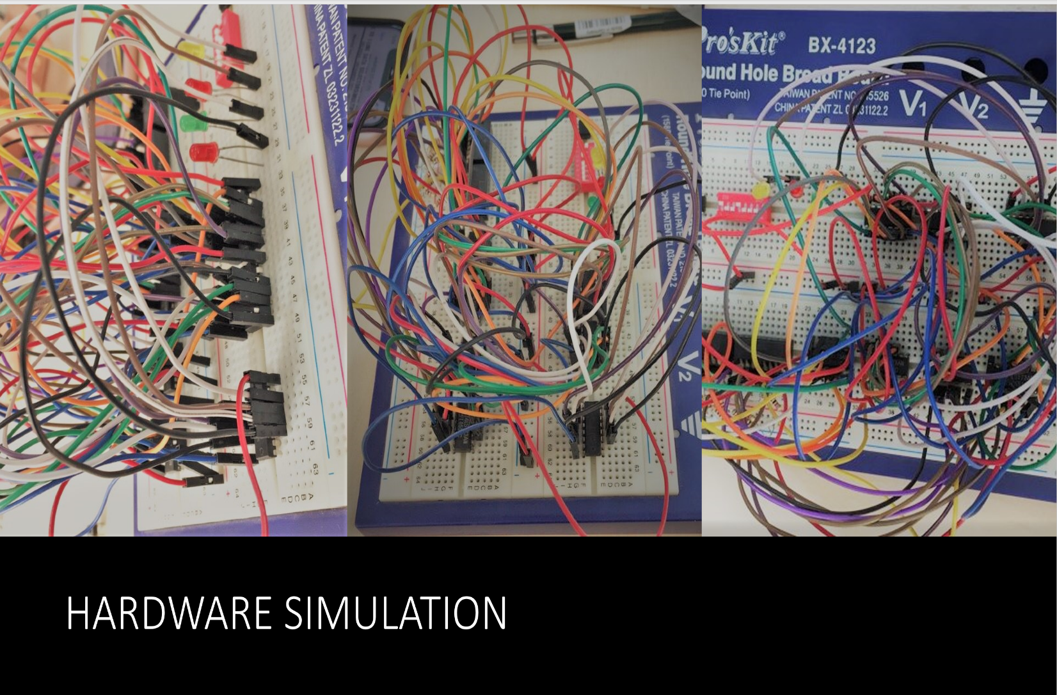Hardware

|  |
| --- |
|  |
| Decorative  **Software implementation on logic works:** |

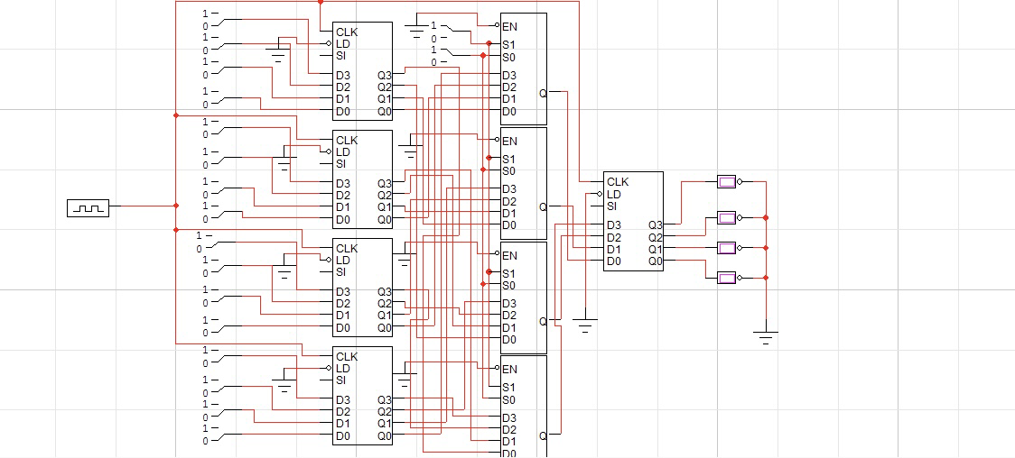

that’s When REGISter A is TURNED ON (FIRST set of 4 SWITCHEs) THe SELECTION LINES OF the MULTIPLexers are 0-0 ACCORDING TO The TRUTH TABLE

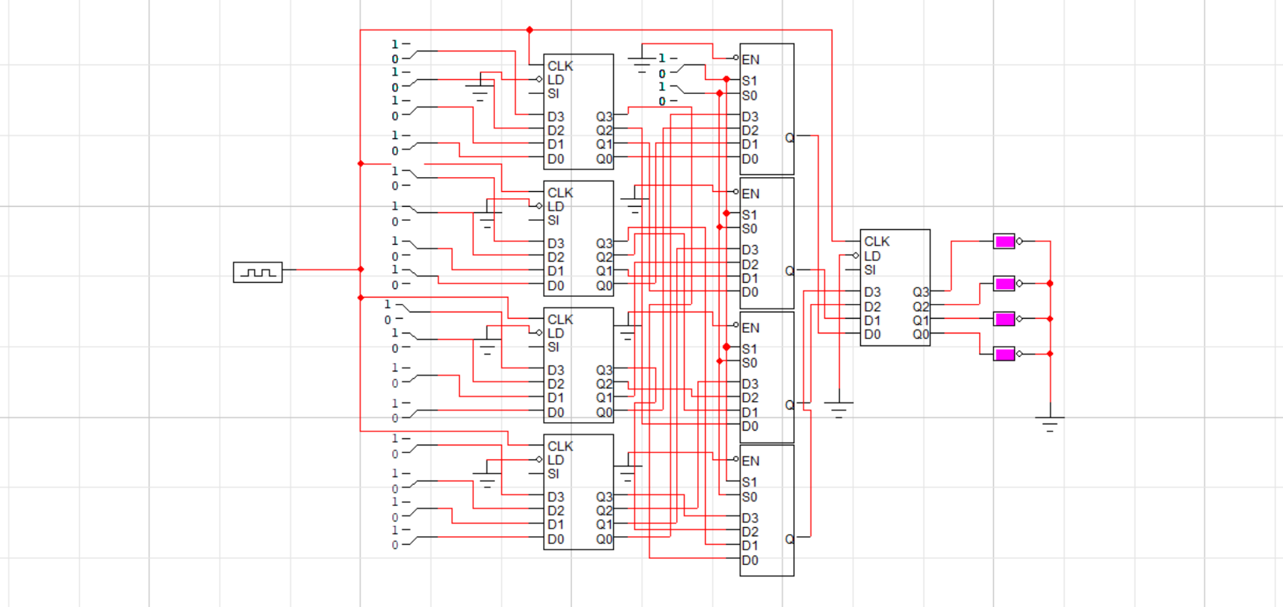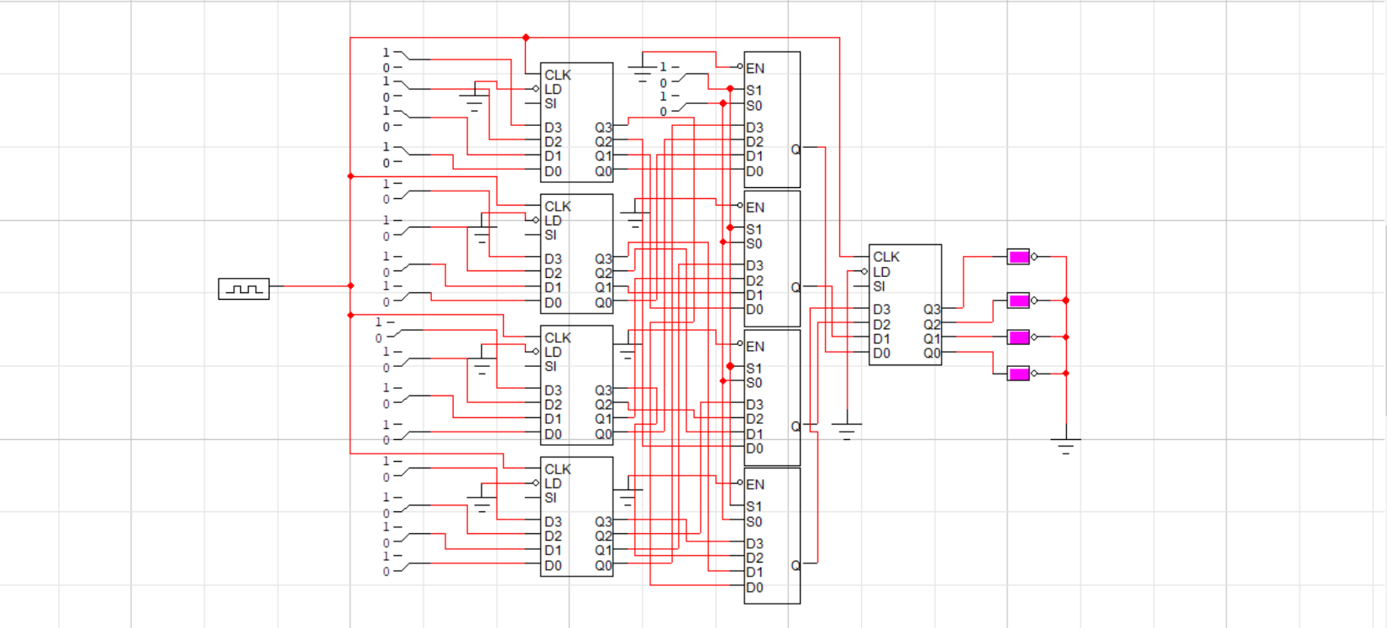

that’s When REGISter B is TURNED ON (Second set of 4 SWITCHEs) THe SELECTION LINES OF the MULTIPLexers are 0-1 ACCORDING TO The TRUTH TABLE

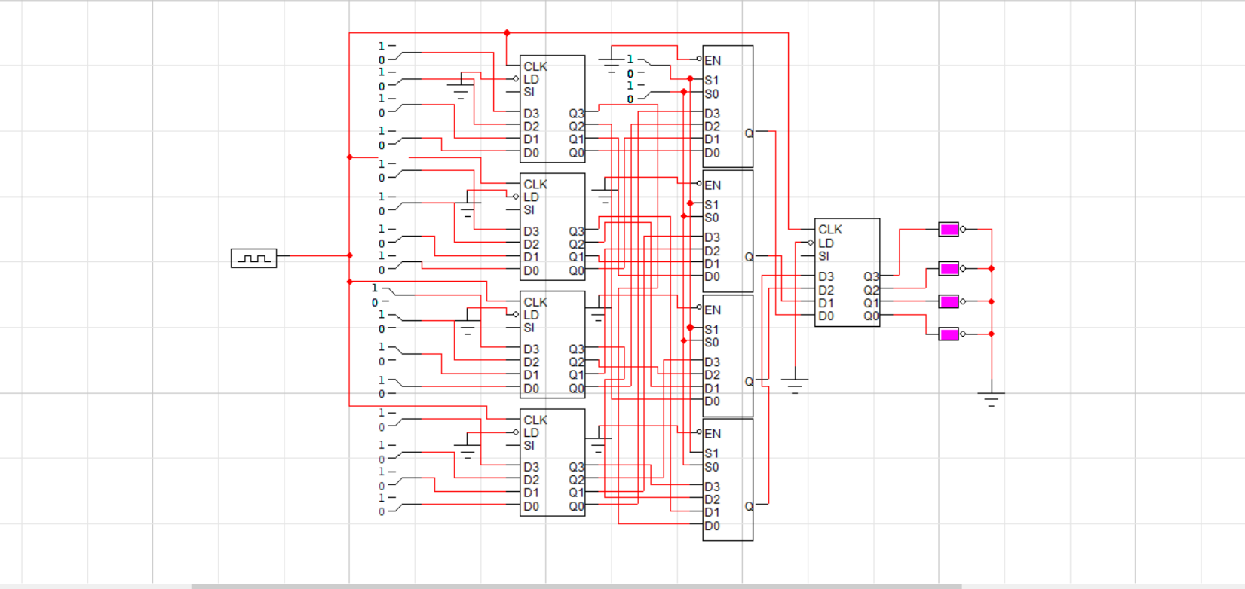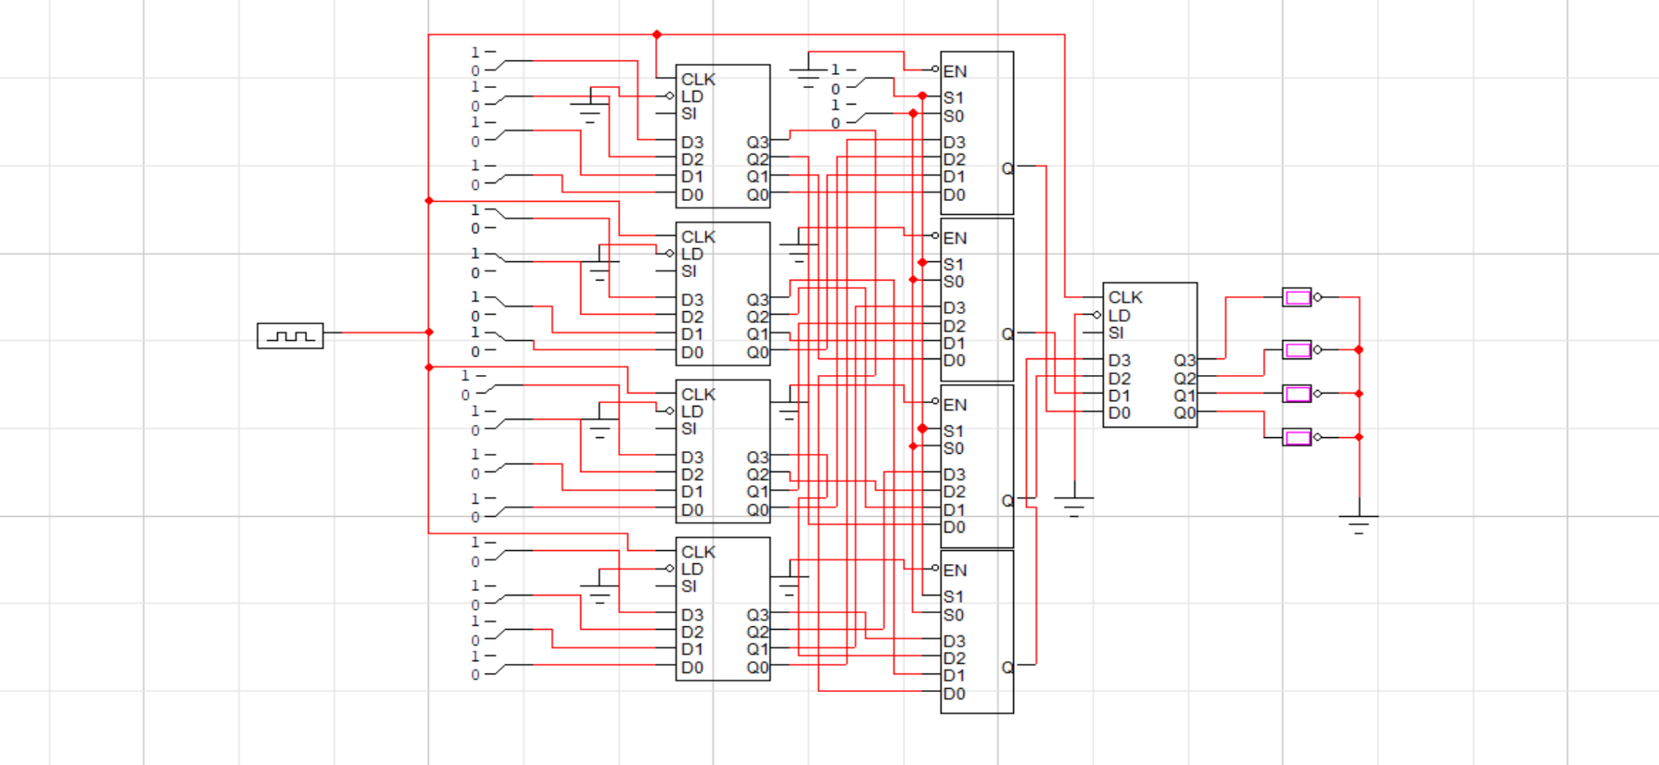

that’s When REGISter C is TURNED ON (Third set of 4 SWITCHEs) THe SELECTION LINES OF the MULTIPLexers are 1-0 ACCORDING TO The TRUTH TABLE

Note:

That the multiplexer input of register B out to destination although it is high, because the selection lines showing Register A

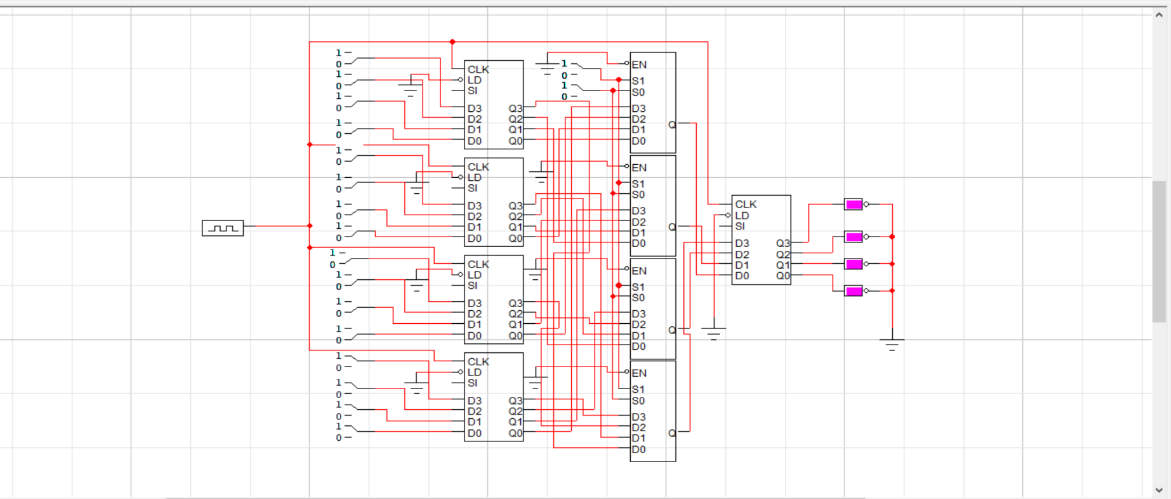

that’s When REGISter D is TURNED ON (Fourth set of 4 SWITCHEs) THe SELECTION LINES OF the MULTIPLexers are 1-1 ACCORDING TO The TRUTH TABLE